Manufacturing Cost and Profitability Analysis – Complete Python Solution
1. Problem Understanding
A manufacturing company wants to calculate the total production cost and profit for its products.
The program considers:
- Raw material costs.
- Labour charges.
- Material wastage.
- Machine operating costs.
- Production quantity.
- Selling price per product.
- Required profit target.
It calculates the total manufacturing cost, cost per product, total revenue, actual profit, profit percentage, and checks whether production meets the specified profit target.
Note: All rates and values used below are imaginary examples for this assignment.
2. Computational Thinking
Input:
- Product name.
- Production quantity.
- Material cost per unit.
- Labour cost per unit.
- Wastage percentage.
- Machine cost per unit.
- Selling price per unit.
- Required profit target.
Processing:
- Calculate total material cost.
- Calculate wastage cost.
- Calculate total labour charges.
- Calculate machine operating cost.
- Calculate total production cost.
- Calculate cost per product.
- Calculate total selling revenue.
- Calculate actual profit and profit percentage.
- Compare actual profit with the required profit target.
Output:
- Material cost.
- Wastage cost.
- Labour charges.
- Machine cost.
- Total manufacturing cost.
- Cost per product.
- Total revenue.
- Actual profit.
- Profit percentage.
- Profit target status.
3. Formulas
Let:
- \(Q\) = Production quantity
- \(M\) = Material cost per unit
- \(L\) = Labour cost per unit
- \(W\) = Wastage percentage
- \(C\) = Machine cost per unit
- \(S\) = Selling price per unit
1. Material cost
\[ \text{Material Cost}=Q\times M \]
2. Wastage cost
\[ \text{Wastage Cost}=\frac{\text{Material Cost}\times W}{100} \]
3. Labour charges
\[ \text{Labour Cost}=Q\times L \]
4. Machine cost
\[ \text{Machine Cost}=Q\times C \]
5. Total manufacturing cost
\[ \text{Total Cost}=M_c+W_c+L_c+C_c \]
6. Cost per product
\[ \text{Cost Per Unit}=\frac{\text{Total Cost}}{Q} \]
7. Total revenue
\[ \text{Revenue}=Q\times S \]
8. Actual profit
\[ \text{Profit}=\text{Revenue}-\text{Total Cost} \]
9. Profit percentage
\[ \text{Profit Percentage}=\frac{\text{Profit}}{\text{Total Cost}}\times100 \]
4. Algorithm
- Start.
- Read product name.
- Read production quantity.
- Read material cost per unit.
- Read labour cost per unit.
- Read wastage percentage.
- Read machine cost per unit.
- Read selling price per unit.
- Read required profit target.
- Calculate material cost.
- Calculate wastage cost.
- Calculate labour charges.
- Calculate machine operating cost.
- Calculate total manufacturing cost.
- Calculate cost per product.
- Calculate total revenue.
- Calculate actual profit.
- Calculate profit percentage.
- Compare actual profit with the required profit target.
- Display the manufacturing report.
- Stop.
5. Flowchart
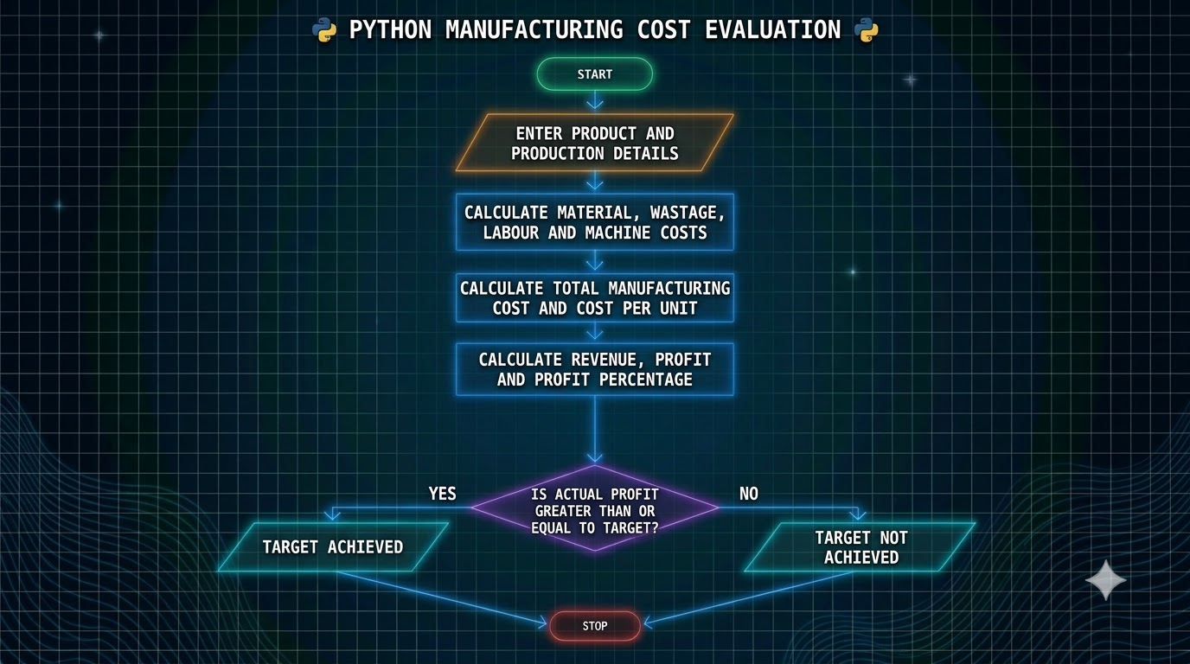
6. Pseudocode
START

INPUT product name
INPUT production quantity
INPUT material cost per unit
INPUT labour cost per unit
INPUT wastage percentage
INPUT machine cost per unit
INPUT selling price per unit
INPUT profit target

IF production quantity > 0 AND
all costs and rates are valid:

material_cost = quantity * material_rate

wastage_cost =
material_cost * wastage_percentage / 100

labour_cost = quantity * labour_rate

machine_cost = quantity * machine_rate

total_cost =
material_cost + wastage_cost +
labour_cost + machine_cost

cost_per_unit = total_cost / quantity

revenue = quantity * selling_price

profit = revenue - total_cost

profit_percentage = profit / total_cost * 100

IF profit >= profit_target:
DISPLAY "Profit target achieved"
ELSE:
DISPLAY "Profit target not achieved"

DISPLAY manufacturing report

ELSE:
DISPLAY "Invalid input"

STOP
7. Complete Python Program
# Manufacturing Cost and Profitability Analysis

# Input product details
product_name = input("Enter product name: ")

quantity = int(input("Enter production quantity: "))

material_rate = float(input("Enter material cost per unit: "))

labour_rate = float(input("Enter labour cost per unit: "))

wastage_percentage = float(input("Enter wastage percentage: "))

machine_rate = float(input("Enter machine cost per unit: "))

selling_price = float(input("Enter selling price per unit: "))

profit_target = float(input("Enter required profit target: "))

# Validate input
if (quantity <= 0 or material_rate < 0 or
labour_rate < 0 or wastage_percentage < 0 or
machine_rate < 0 or selling_price < 0 or
profit_target < 0):

print("\nInvalid production details.")
print("Please enter valid positive quantity and non-negative values.")

else:

# Calculate material cost
material_cost = quantity * material_rate

# Calculate wastage cost
wastage_cost = material_cost * wastage_percentage / 100

# Calculate labour charges
labour_cost = quantity * labour_rate

# Calculate machine cost
machine_cost = quantity * machine_rate

# Calculate total manufacturing cost
total_cost = (material_cost + wastage_cost +
labour_cost + machine_cost)

# Calculate cost per product
cost_per_unit = total_cost / quantity

# Calculate total selling revenue
revenue = quantity * selling_price

# Calculate actual profit
profit = revenue - total_cost

# Calculate profit percentage
if total_cost > 0:
profit_percentage = (profit / total_cost) * 100
else:
profit_percentage = 0

# Store cost details in a list
cost_details = [
["Material Cost", material_cost],
["Wastage Cost", wastage_cost],
["Labour Cost", labour_cost],
["Machine Cost", machine_cost]
]

# Display manufacturing report
print("\n====== MANUFACTURING REPORT ======")

print("Product Name:", product_name)
print("Production Quantity:", quantity)

for item in cost_details:
name, amount = item
print(name, ": Rs.", round(amount, 2))

print("----------------------------------")

print("Total Manufacturing Cost: Rs.",
round(total_cost, 2))

print("Cost Per Product: Rs.",
round(cost_per_unit, 2))

print("Selling Price Per Product: Rs.",
round(selling_price, 2))

print("Total Revenue: Rs.",
round(revenue, 2))

print("Actual Profit: Rs.",
round(profit, 2))

print("Profit Percentage:",
round(profit_percentage, 2), "%")

# Check profit target
print("\n====== PROFITABILITY RESULT ======")

if profit >= profit_target:

print("Profit Target: Rs.", profit_target)
print("Status: PROFIT TARGET ACHIEVED")

else:

shortage = profit_target - profit

print("Profit Target: Rs.", profit_target)
print("Status: PROFIT TARGET NOT ACHIEVED")
print("Additional Profit Required: Rs.",
round(shortage, 2))

# Store final details in a tuple
production_summary = (
product_name,
quantity,
total_cost,
revenue,
profit,
profit_percentage
)

# Tuple unpacking
(name, units, cost, sales,
actual_profit, percentage) = production_summary

print("\n====== FINAL SUMMARY ======")
print("Product:", name)
print("Units Produced:", units)
print("Production Cost: Rs.", round(cost, 2))
print("Sales Revenue: Rs.", round(sales, 2))
print("Net Profit: Rs.", round(actual_profit, 2))
8. Sample Input
Enter product name: LED Bulb

Enter production quantity: 1000

Enter material cost per unit: 50

Enter labour cost per unit: 10

Enter wastage percentage: 5

Enter machine cost per unit: 8

Enter selling price per unit: 90

Enter required profit target: 15000
9. Step-by-Step Calculation
Given:
- Production quantity = 1,000 units
- Material cost = ₹50 per unit
- Labour cost = ₹10 per unit
- Wastage = 5%
- Machine cost = ₹8 per unit
- Selling price = ₹90 per unit
- Required profit = ₹15,000
Step 1: Material cost
\[ 1000\times50=₹50,000 \]
Step 2: Wastage cost
\[ 50,000\times\frac{5}{100}=₹2,500 \]
Step 3: Labour cost
\[ 1000\times10=₹10,000 \]
Step 4: Machine cost
\[ 1000\times8=₹8,000 \]
Step 5: Total manufacturing cost
\[ 50,000+2,500+10,000+8,000 \]
\[ =₹70,500 \]
Step 6: Cost per product
\[ 70,500/1000=₹70.50 \]
Step 7: Total revenue
\[ 1000\times90=₹90,000 \]
Step 8: Actual profit
\[ 90,000-70,500=₹19,500 \]
Step 9: Profit percentage
\[ \frac{19,500}{70,500}\times100=27.66\% \]
Step 10: Profit target comparison
- Actual profit = ₹19,500
- Required profit = ₹15,000
Since ₹19,500 is greater than ₹15,000, the profit target is achieved.
10. Sample Output
====== MANUFACTURING REPORT ======

Product Name: LED Bulb
Production Quantity: 1000

Material Cost : Rs. 50000.0
Wastage Cost : Rs. 2500.0
Labour Cost : Rs. 10000.0
Machine Cost : Rs. 8000.0

----------------------------------

Total Manufacturing Cost: Rs. 70500.0
Cost Per Product: Rs. 70.5
Selling Price Per Product: Rs. 90.0
Total Revenue: Rs. 90000.0
Actual Profit: Rs. 19500.0
Profit Percentage: 27.66 %

====== PROFITABILITY RESULT ======

Profit Target: Rs. 15000.0
Status: PROFIT TARGET ACHIEVED

====== FINAL SUMMARY ======

Product: LED Bulb
Units Produced: 1000
Production Cost: Rs. 70500.0
Sales Revenue: Rs. 90000.0
Net Profit: Rs. 19500.0
Final Result: Profit Target Achieved
11. Additional Test Cases
Test case | Actual profit | Target | Expected result
1 | ₹19,500 | ₹15,000 | Achieved
2 | ₹10,000 | ₹15,000 | Not achieved
3 | ₹15,000 | ₹15,000 | Achieved
4 | ₹0 | ₹5,000 | Not achieved
5 | Loss of ₹2,000 | ₹5,000 | Not achieved
12. Assigned Syllabus Concepts Used
Syllabus topic | Application
Computational thinking | Dividing manufacturing calculations into smaller tasks
Algorithms | Step-by-step calculation process
Flowcharts | Visual representation of logic
Pseudocode | Planning program instructions
Variables | quantity, material_cost, profit
Data types | Integer, float, string
Operators | +, -, *, /, >=
Conditional statements | if, else
Loops | for loop for displaying cost details
Strings | Product name and report messages
Pattern generation | Not required in this problem
Lists | Storing manufacturing costs
Nested lists | Storing cost names and values
Tuples | Storing final production summary
Tuple operations | Accessing and storing summary details
Unpacking | Separating tuple values into variables
Important assignment note: This program assumes all produced units are sold at the same selling price. Wastage is calculated as a percentage of material cost, and labour and machine charges are calculated per produced unit. These assumptions make the calculations clear and suitable for a first-year Python assignment.

